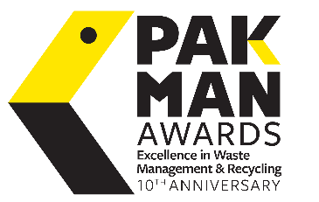

2024 Pakman Awards Entry Template

Notes:
Please find below sample content that may be included within your Pakman Awards entry in any given category. Entries should be no more than 4 pages in length and may be submitted in either word or PDF file formats.
It is recommended that imagery is provided in the form of graphs/charts (if applicable) to demonstrate the initiatives/project outlined in your entry. Please ensure that consent to use imagery has been obtained prior to inclusion within the entry, as winning entries may be displayed on our site - Pakman.ie.

Section 1: Background/Overview of Entry
- Provide a brief description of the organisation/community group/school/individual involved
- Outline the chosen category and rationale for entering

Section 2: Description of Initiative/Project
- Provide a detailed description of the steps involved in the set up and running of the project/initiative
- Showcase evidence of how the project/initiative was effectively communicated to all parties involved
- Describe how the project/initiative aligns to the overall sustainability strategy of the organisation/community group/school/individual

Section 3: Achievements to Date
- Outline achievements to date and the effects of the project/initiative
- Provide examples of elements of the project/initiative that have exceeded expectations and highlight the organisation/community group/school/individual’s overall commitment to sustainability/recycling excellence and waste management

Section 4: Future Focus
• Detail what future goals are in place for the project/initiative, if applicable, or provide an outline of future plans for the organisation/community group/school/individual’s overall sustainability strategy

